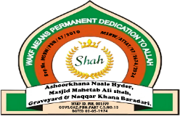

AshoorKhana Naale Hyder, Masjid Mahetab Ali Shah,
MSBW/PBN/47/2010
Graveyard & Naqqar Khana Baradari
Sajjada Nashine & Mutawalli –Mushtaque Ali Shah, +91 9421488111, +91 9119488111.
Office: Lokmanya Tilak Road, Parbhani. Contact – anhparbhani123@gmail.com,

जा.क्र.ANH/PBN/202 -2 / दिनांक. / /

